

|  |  |  |  |  |  |  |
| --- | --- | --- | --- | --- | --- | --- |
| SiteNet / SmartNet  RBU Software  Build INstructions  2008-PRO-0001 Rev 01  October 2024 | | | | | | |
| Document No: | | 2008-PRO-0001 | Client Ref: |  | | |
| Document revision history | | | | | | |
| Rev | Description | | Date | Author | Checked | Approved |
| 01 | First issue | | 18/10/2024 | Nilesh Thakare | Atendra Pathak |  |
|  |  | |  |  |  |  |
|  |  | |  |  |  |  |
|  |  | |  |  |  |  |
|  |  | |  |  |  |  |
|  |  | |  |  |  |  |
|  |  | |  |  |  |  |
|  |  | |  |  |  |  |
|  |  | |  |  |  |  |
| HARD COPIES ARE UNCONTROLLED  Controlled copies of this document are only issued in the PDF format that includes digital signatures of the author, checker and approver. These signatures can be viewed in Adobe Acrobat. The document will be digitally marked if it has been altered since signing. In order for recipients of documents to verify digital signatures, digital signature certificates may be requested from Cygnus Group Ltd. | | | | | | |

Contents

1 CIE PANEL Binaries 2

2 Scatter File 3

3 Build Process 3

# CIE PANEL Binaries

There are 2 build outputs are generated and can be used to put into CIE panel.

CIE_Panel.hex – This file can be downloaded into CIE panel using ST programmer.

CIE_Panel.dfu – This file can be downloaded to CIE panel using configuration tool.

Both the output files are generated when we compile the CIE source code using Keil development tool.

The two bootloaders are built separately, both put their binaries into their ‘objects’ folder.

Before stating the build, it runs the 2 scripts for version number and time batch file. Then CIE software project builds the source code, then runs the post-script. The scripts are set in the project settings on the ‘User’ tab, as shown.

The first pre-build script “VersionNumber.exe” gets the existing version number from “version.txt” and update the new version by incrementing it into “version.h”.

When the project is compiled ”CIE_Panel.hex” is generated and this generated file is used as an input by the script “CreateDFU” to generate the “CIE_Panel.dfu” along with version number mention in the user command.

The scripts are found in the project, in folder “.\CIE_PANEL\CIE_Panel_F7\MDK-ARM”. In order to generate the “CIE_Panel.dfu” file correctly file “STDFUFiles.dll” must be available at this this project folder path.

# Scatter File

The scatter file is used to set the memory layout for the CIE panel code. It is located in folder \CIE_Panel_F7\ScatterFiles. It is added to the project settings on the linker tab as shown below

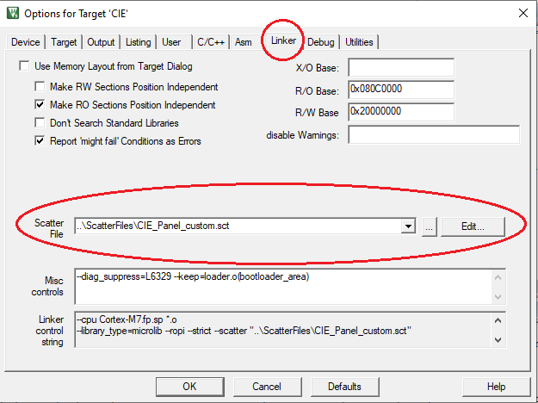

They just set the ROM and RAM address ranges, including special purpose areas like the RAM that doesn’t get initialised on start-up.

# Build Process

When the system works i.e. usually, but not always, we follow this process:

1. Raise a Jira for the problem.
2. Create a branch, ideally off the Master in GitHub. Start the branch name with the Jira number.
3. Fix the problem.   
   (If the issue belongs to Panel GUI then fix the issue in panel GUI project given in folder **“PanelGUI”** and then compile the PanelGUI project using “Embedded wizard” to generate the code).
4. Build the release version.
5. Commit the source code changes to the GitHub.
6. Open the GitHub and copy the commit hash for the committed Jira number branch.
7. Go to releases section on GitHub and create a release for the build.
8. Attach the generated build file to the release (CIE_Panel.hex and CIE_Panel.dfu).
9. Push the branch back into GitHub.
10. Inform to validation team that the build is ready for validation.
11. After Validation team has completed the testing, merge the branch onto the Master in GitHub.

The CIE software area on the network is found at:

\DWS Group\Cygnus Group Sharepoint - Documents\Dev\2000 - SmartNet Controlled\Draft\SW\2008-SW-0001 CIE